PROPERTY ADDRESS APPLYING FOR: _____________________________________________________
ITEM 1:
Weekly Rent Amount: | $ | Bond:  (4 weeks rent) | $ | Lease Term:
Lease Start Date:
CONTACT DETAILS:

ITEM 2:
Full Name:
Contact No: |  |  | Date of Birth:
Drivers Licence No: |  |  | Passport No:
Email:
No of Vehicles: |  |  | Registration No:
ITEM 3:
DEPENDANTS: Do you have any children? YES / NO

Dependants Full Name | Dependants Date of Birth
ITEM 4:
SMOKING: Are you or any of the dependants living with you a smoker? YES / NO

PETS: Do you intend to keep pets at the property? YES / NO
ITEM 5:

No. of Pets | Breed | Age of Pet | Inside or Outside | Is the pet registered with Council | Is the Pet Desexed

ITEM 6: :
CURRENT ADDRESS DETAILS
Current Address:
Circle which applies | Renting with Agent | Private Landlord | Living at Home | Other:
Period of Occupancy: | _____ years _____ months | Lease End Date:
Are you named on the Lease: | YES / NO | Current Rental Amount: | $ per week
Agency/Landlord Name:
Agency/Landlord Email:
Reason for Leaving:

PREVIOUS ADDRESS DETAILS (If above occupancy is less than 2 years)

Current Address:
Circle which applies | Renting with Agent | Private Landlord | Living at Home | Other:
Period of Occupancy: | _____ years _____ months | Lease End Date:
Are you named on the Lease: | YES / NO | Current Rental Amount: | $ per week
Agency/Landlord Name:
Agency/Landlord Email:
Reason for Leaving:

EMPLOYMENT DETAILS (SELF EMPLOYED SEE NEXT PAGE)
ITEM 7: :

Are you employed? | YES / NO | Employment Status: |  | Full Time | Part Time | Casual
Company Name:
Contact Name:
Contact No: |  | Your Position:
Income (after tax) | $ per week | Date Commenced:
ITEM 7:
EMPLOYMENT DETAILS - If you are SELF EMPLOYED

Name of your business:
Description of your business:
Year your business started:
PLEASE INCLUDE A BANK STATEMENT OR MOST RECENT TAX RETURN/FINANCIAL YEAR STATEMENTAS PROOF OF INCOME
ITEM 8: :
CENTERLINK PAYMENT:

Are you receiving regular Centrelink payments?
Description of payment/s:
Total amount of payment: | $ per Week | Fortnight | Month

STUDENT DETAILS
ITEM 9:

Are you studying?
Name of Course:
Name of Institution:
Are you an International Student:
Visa Expiry Date:

PERSONAL REFERENCES & EMERGENCY CONTACT
ITEM 10: :

Please DO NOT list relatives, another applicant or partners and provide business hours contact numbers
Referee Name: | Number:
Emergency Contact: | Number:
ITEM 11: :
CONFIRMATION OF APPLICANTS

Name of all applicants who will be residing at this property:

FULL NAME | RELATIONSHIP TO YOU

SUPPORTING DOCUMENTATION
ITEM 13 :
Identification - You are required to meet identification criteria upon submission of your application. The agent/lessor may photocopy any item and retain as part of your application.

Please supply one item from Column A & B PLUS all documentation under your employment category

Column A |  | Column B | Employed | Self Employed | Not Employed
Passport | Driver’s License | Medicard Card | Last pay slip | Bank statement | Bank statement
Proof of Age Card | Student Photo ID | Utility/Phone Bill |  | Accountants Letter | Centrelink Statement
 |  | Full Birth Certificate |  | Tax Return
 |  | Bank Statement
 |  | Tenancy Ledger
 |  | Rates Notice

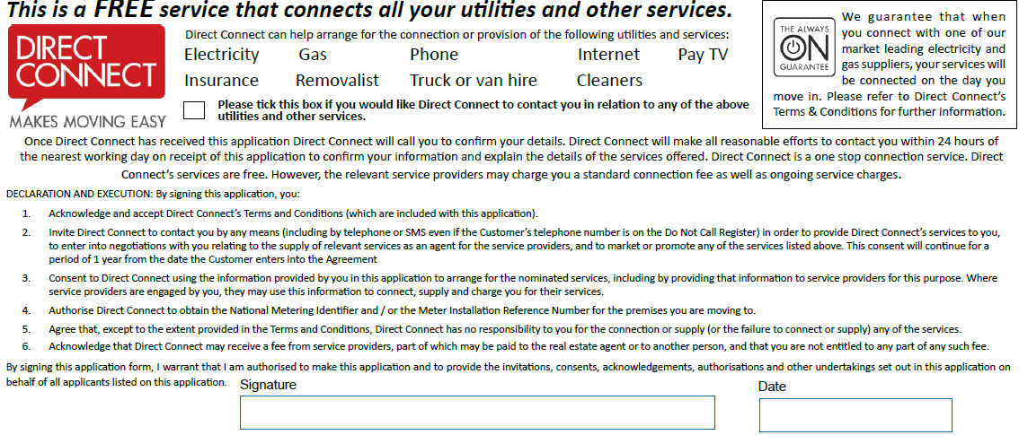

Declaration - Please declare the following by answering TRUE or FALSE
I, the applicant,
Have never been evicted by an agent/lessor TRUE / FALSE
Have no known reasons that would affect my ability to pay rent TRUE / FALSE
Was refunded the rental bond for my last address in full (if applicable) TRUE / FALSE
If false, please advise what deductions were made from your bond
Have no outstanding debt to another agency/lessor TRUE / FALSE
If false, why?

Acknowledgement and Consent to the following by selecting either YES or NO
I, the applicant,
 |  | YES | NO
 | Acknowledge that I have been made aware of Home Co Privacy Policy. Available from the Home Co. office or at www.myhomeco.com.au - With relevance to the use of points 2 – below. | ☐ |  | ☐
 | Consent and understand that should my tenancy be accepted and upon commencement of the tenancy agreement, there may be cause for the agent/lessor to pass my details onto others which may include (but is not limited to) insurance companies, body corporates, contractors, other real estate, salespeople and tenancy default databases. | ☐ |  | ☐
 | Consent and understand that Home Co. has collected this information for the purposes of ascertaining whether I am a suitable tenant for the property applied for. This will include verifying my identity, my ability to care for the property, my character and my creditworthiness. | ☐ |  | ☐
 | Authorise Home Co. to contact the persons named in this application, and to undertake such enquiries and searches as you consider reasonably necessary. | ☐ |  | ☐
 | In doing so, I understand that information provided by me may be disclosed to, and further information obtained from, referees named in this application and other relevant third parties. | ☐ |  | ☐
 | Acknowledge and accept that if this application is denied, the agent is not legally obliged to provide reasons as to why. | ☐ |  | ☐
 | Acknowledge that the lessor and applicant (tenant) are bound by this agreement immediately upon communication of either the lessor or agent’s acceptance of the application. | ☐ |  | ☐
 | Acknowledge that I may view Information Statement (form 17a) via the RTA website. | ☐ |  | ☐
 | Acknowledge that the offer has been made available to view the General Tenancy Agreement (form 18a), the standard terms and any special conditions before completing this application | ☐ |  | ☐
 | Acknowledge that my personal contents insurance is not covered under any lessor insurance policy/s and understand that it is my responsibility to insure my own personal belongings | ☐ |  | ☐
 | Consent to the use of email and facsimile in accordance with the provisions set out in Chapter 2 of the Electronic Transactions (Queensland) Act 2001 (Qld) and the Electronic Transactions Act 1999 (Cth). | ☐ |  | ☐
 | Declare that the above information is true and correct and that I have supplied it of my own free will | ☐ |  | ☐

Name of Applicant: _________________________________________________ Date: ______________________

Signature: _____________________________________________________________________________________

I, _____________________________________________________________________________________________

have read and understood the attached information. I authorise employees of Home Co., and independent contractors of Home Co. including their directors, officers and employees, to obtain relevant information from, and release relevant information to, the parties described on this document to assist with my involvement with Home Co. I understand that I can revoke my authority at any time. I acknowledge that if I revoke my authority, or if I decline to provide information as requested by Home Co., Home Co. may be unable to provide the products or services I have requested.

Signature: ________________________________________________ Date: ____________________________________

Parent/Guardian Signature (if under 18 years of age): _______________________________________________________

Privacy
HomeCo. Residential Pty Ltd (ACN 629 873 641) trading as HomeCo. Residential is committed to protecting your privacy in compliance with the Privacy Act 1988 (Cth) and the Australian Privacy Principles (APPs). This document sets out Home Co. condensed Privacy Notice. Home Co. also has a full Privacy Policy, which contains information about how you can complain about any breach by Home Co. of the APPs or an applicable APP Code.

A full copy of our Privacy Policy can be accessed at www.myhomeco.com.au

Information Collection, Use and Disclosure
During the course of your involvement with Home Co., we may collect, use or disclose personal information about you for the following purposes:

- Assisting you to sell your property;
- Assisting you to purchase a property;
- Assisting you to lease a property (either as lessor or lessee);
- Assisting you to obtain a loan;
- Assisting you with payment or refund of a bond;
- Assisting you with tenancy disputes;
- Coordinating repairs or maintenance of a property owned or leased by you;
- Recording or accessing information at the Titles Registry Office or other government agency;

- Recording or accessing information on tenancy information services or databases;
- Client and business relationship management;
- Marketing of products and services to you;

The types of personal information we may collect, use or disclose about you includes but is not limited to:
- Your full name;
- Your date of birth;
- Your residential address;
- Your postal address;
- Your email address;
- Your home telephone number;
- Your work telephone number;
- Your mobile telephone number;
- Your occupation and business address;
- Financial information including details of your employer, income, name of bank or financial institution;
- Details of your spouse, de facto, dependent children, and roommates;
- Details of properties owned by you;

In order to provide products and services to you, we may disclose your personal information to the persons/organisations described below:

- In the event that you are a seller or a lessee, we may disclose your personal information to prospective buyers of the property owned or leased by you;
- In the event that you are a buyer or a lessee, we may disclose your personal information to the sellers of the property you are purchasing or leasing;
- Your legal advisor(s) and the legal advisor(s) representing the other party(s) involved in your transaction;
- Your financial institution and/or financial advisor;
- Insurance providers and brokers;
- Utility providers and utility connection service providers;
- Persons or organisations involved in providing, managing or administering your product or service including independent contractors engaged by us as real estate;
- Tradespeople engaged by us to repair or maintain a property owned or leased by you;
- Organisations involved in maintaining, reviewing and developing our business systems, procedures and infrastructure including maintaining or upgrading our computer systems;
- Persons or organisations involved in purchasing part or all of our business;
- Our related companies;
- Organisations involved in the payments systems including financial institutions, merchants and payment organisations;
- The Titles Registry Office or other government agencies;
- The Residential Tenancies Authority;
- Police;
- Tenancy information services or databases;
- Real estate websites;
- Real estate peak bodies;

Whenever it is reasonable or practicable to do so, we will collect your personal information directly from you. Sometimes it will be necessary for us to collect information from a third party or a publicly available
source, such as a credit reporting agency, your legal adviser, your past or current employers, your previous lessors or property managers, and tenancy information services or databases.

In the course of providing services to you, it may be necessary for us to enter your personal information into forms generation software and real estate websites. Depending on the terms of use of such software and websites, a third party may acquire rights to use or disclose information entered into the relevant forms or websites.

We may disclose your personal information to recipients within Australia or to overseas recipients. Should information be required to be sent interstate or overseas, we will take steps to protect the privacy of your information.

We need your permission to collect, use and disclose your personal information, and we therefore ask that you sign the consent on the first page of this document to indicate your consent.

In the event that you do not consent to Home Co. collecting and releasing your personal information as described above, we may be unable to provide the services requested by you.

Access to, and correction of personal information
You have the right to request access to your information and to request that Home Co. update or correct your personal information. A charge may apply for providing access to your information.

Our Privacy Policy contains further information about how you may request access to, and correction of, your personal information.

Contacting Us
You may contact us by mail, email or telephone as follows:

901/59 Endeavour Blvd, North Lakes, Qld 4509
59 Flinders Lane, Maroochydore

0412 709 928 or 0421 717 155

hello@myhomeco.com.au

